ARC Week at Glance
Subject: Math Course: Advanced Algebra Concepts & Connections Grade: 9th – 12th Dates: 3/31 to 4/4
Standard(s):
AA.GSR.7 Develop an introductory understanding of the unit circle; solve trigonometric equations using the unit circle.
AA.GSR.7.1 Define the three basic trigonometric ratios in terms of x, y, and r using the unit circle centered at the origin of the coordinate plane.
Assessment(s): ☐ Quiz ☐ Unit Test ☐ Project ☒ Lab ☐
 | Learning Target  (I am learning about…) | Criteria for Success  (I can…) | Opening  (10 - 15 Mins) | Work-Session  (20 - 25 mins) | Closing  (5 - 10 mins) | Literacy Tasks/Focus
 | Learning Target  (I am learning about…) | Criteria for Success  (I can…) | (Include at least one/two formatives*in any part of the lesson as needed) |  |  | Literacy Tasks/Focus
Monday | I am learning about the unit circle. | I can sketch angles in standard position on the unit circle and determine their coordinates | Exploring the Unit Circle Task Diagnostic  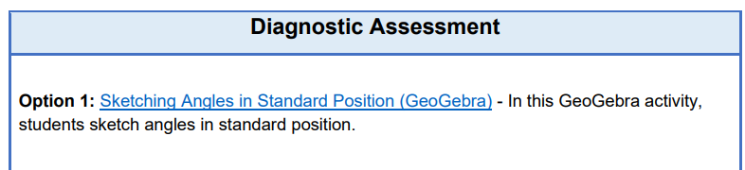  (Option 1: Sketching Angles in Standard Position GeoGebra) | Exploring the Unit Circle Task-  Complete Explore Problems  with a partner | Check work, share exemplars and do nots. | How do you remember the endpoints with these special right triangles?
Tuesday | I am learning how to use the unit circle. | Students will use basic trig functions to solve real-world problems. | Exploring the Unit Circle Task  Desmos Activity  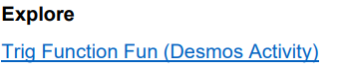 |  |  | Self-evaluation: Copy Desmos Slides 18 – 20 into your notes
Wednesday | I am learning how to use the unit circle. | Students will use basic trig functions to solve real-world problems. | Share and view students’ reflections from Desmos slides 18 - 20 | Exploring the Unit Circle – Apply Hiking - You are planning a hiking trip and want to determine | Exploring the Unit Circle - Reflect | Exploring the Unit Circle - Reflect
Thursday | M.A.P. Testing Block Schedule  Teacher schedules will vary!
Friday
*☐ Exit Ticket/Final Stretch Check ☒ Electronic Tools ☐ Dry Erase Boards – quick checks ☐ Turn & Talk Discussion (verbal responses) ☐ Teacher Observation – document Clipboard
☐ Quick Write/Draw ☐ Annotation ☐ Extended Writing ☐ Socratic Seminar ☐ Jigsaw ☐ Thinking Maps ☒ Worked Examples ☐ Other : ___________

